ASSEMBLING
the
ECEbot

Chassis Mechanical Assembly

Due Date:

Prepared by R.C. Maher
October 2008

Copyright © 2008 Department of Electrical and Computer Engineering, Montana State University
All Rights Reserved

Base Plate Preliminaries
The chassis materials consist of:
1 Roller ball caster 1 PCB base plate
2 Servo motors 2 Wheels, screws, and rubber tire bands
4 1½" aluminum stand-offs (cylinders) 7 $3\text{16}$" 4-40 screws
4 small 4-40 "L" brackets 8 $14$" 4-40 screws

Also, note that you will not install the bumper board yet. That installation will happen later when the main PCB is completed, but for now, double-check that your bumper board is equipped with the following:
2 6-32 "L" brackets
4 ¼" 6-32 screws

NOTE: do NOT discard any extra parts from the wheel and motor kits. Some of these will be used later on.

Chassis Step 1: Attach Roller Ball Caster to the Base Plate
Figure 1 shows the basic format of the PCB base plate. In EE101 we won't be doing any soldering on this PCB, but note that there are connections you could use for your own custom circuits once you learn more about electronics!
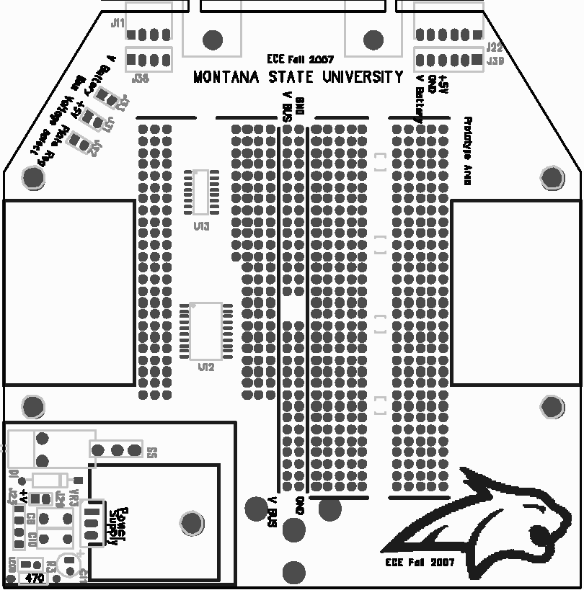
Figure 1: Base plate layout
Front of robot
Rear of robot

Hint: to help recognize the screw sizes, keep in mind that the 4-40 size screws are smaller in shaft diameter and have finer thread pitch compared to the 6-32 screws. And note that $3\text{16}$" is shorter than ¼" when separating the 4-40 screws!

Place the roller ball below the rear of the base plate and align its three legs with the three corresponding mounting holes in the base plate (see Figure 2). Carefully secure the roller ball in place using three of the $3\text{16}$" 4-40 size screws. Use Loctite on the screw threads, if provided.
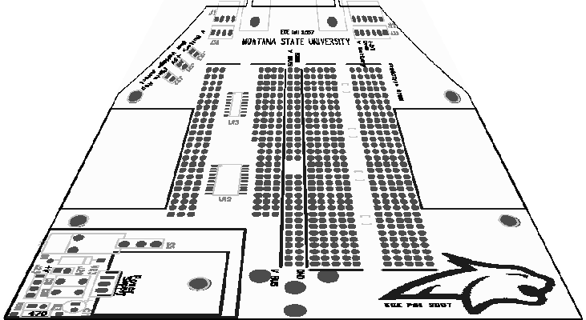
Figure 2: Roller ball caster installation

Chassis Step 2: Attach Stand-offs and Brackets to the Base Plate.
The 1½" cylindrical stand-offs and small "L" brackets attach to the base plate with $14$" 4-40 screws inserted from below, as shown in Figure 3. Just tighten the screws finger-tight for now.
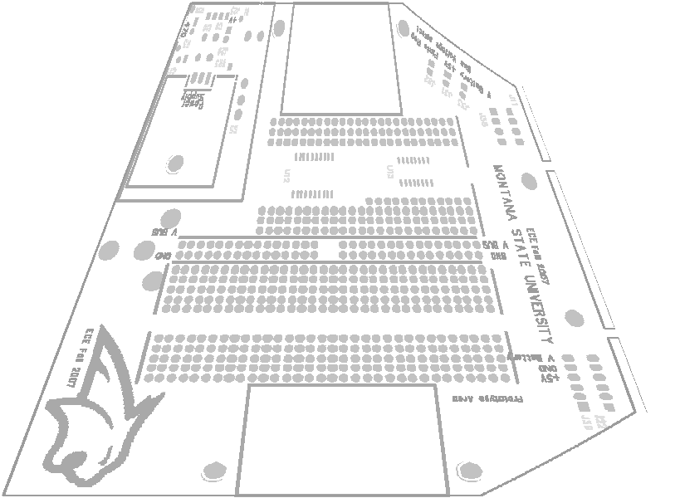
Figure 3: Stand-off, bracket, and screw attachment, right side (repeat for left side)
" 4-40
Once the two right side stand-offs and brackets are installed, repeat for the two stand-offs and brackets on the left side. You won't be mounting the top PCB yet, so keep the 4 4-40 screws for the top of each stand-off either in your parts kit or temporarily screw them into the stand-offs for safe keeping.

Chassis Step 3: Mounting the Motors onto the L brackets
Locate the two servo motors from your parts kit. Each servo motor attaches with two $3\text{16}$" 4-40 screws using the small L brackets just installed in Step 2.
Place the servo motor so that the axle position is toward the front of the robot, as shown in Figure 4.

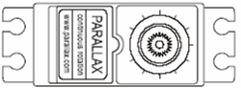
Insert a screw through the lower flange of the motor and line it up with the small "L" bracket sandwiched below the stand-offs. Now adjust the alignment of the motor, brackets, and stand-offs, then tighten (but do not overtighten) the screws—use Loctite liquid (if provided in the lab) on the stand-off screws and the motor screws.
Note: axle position forward
" 4-40 screws go through motor flange and into
"L" bracket

Figure 4: Motor installation, right side (repeat for left side)

Chassis Step 4: Attach the Wheels
The last step is to attach the wheels. Get the two wheels from the kit and attach each wheel to a servo axle. Secure the wheel to the servo with a small screw. Finally, place the rubber "tire" band onto each wheel.

This completes the chassis construction steps. The printed circuit board, microcontroller board, bumper board, and batteries will be mounted during a later lab session.

