ASSEMBLING
the
ECEbot

Bumper Switch Assembly

Due Date:

Prepared by R.C. Maher
October 2008

Copyright © 2008 Department of Electrical and Computer Engineering, Montana State University
All Rights Reserved

Small PCB Preliminaries
One way your robot can move autonomously from place to place is to have bumper switches on the front: if the robot hits something, the switch gets closed, and the robot's microcontroller can command the motors to back up and turn. Your robot will have two bumper switches mounted on the forward "L" brackets.
The bumper switch circuit boards you will assemble contain just a few components. The simple circuit diagram is shown below.
10 kΩ
S2
V_{cc}
= 5 V
GND
= 0 V

The switch is normally open. In this configuration the signal S2 is 'high' because the node is connected to +5 V (V_{cc}) through the 10 kΩ resistor: since no current flows in the resistor Ohm's Law says that the voltage across the resistor must be zero, so S2 must be at the same voltage as V_{cc}. If the switch gets bumped or pushed, the switch closes and S2 is pulled 'low' because that node is connected to 0 volts (ground) by the switch, and current flows through the 10 kΩ resistor from V_{cc} to ground.
The S2 signals from the left and right bumper switch sensors are connected to one of the digital input pins on the microcontroller. The program running on the microcontroller can test the state of the signal to see if it is high or low, and then take some action in response.
The bumper switch circuits consist of:
1 Small printed circuit board (rectangular)
2 10 kΩ ¼ watt resistors (Brown Black Orange Gold)
2 Large pushbutton switches
1 4-pin header set and 1 6-pin header set
4 ¼" 6-32 Phillips head screws
2 right angle brackets
2 hub flanges (from motor kits)

Step 1: Resistor Placement
First, install the 10 kΩ resistors at positions R8 and R9. For consistency and easier identification later, choose the resistor orientation so that the first color band is at the top. Insert the resistors from the silk screen side and solder them to the back. Gently clip off the excess wire.

Step 2: Switch Mounting
→ On the silk screen side, place each switch into position (mounting pins oriented up-and-down), as shown in Figure 1. Flip the board over and solder the pins to the back side. Do not overheat the pins: the switch body will melt if excessive heat is applied!
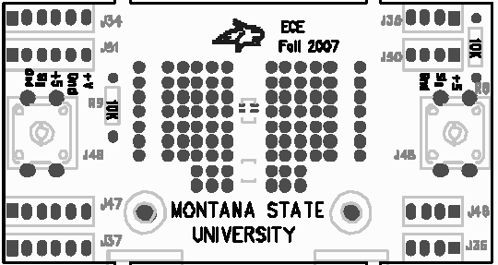
8
Figure 1: Mounting position for the switches

Step 3: Header Connections
The bumper board will connect to the ECEbot main PCB using multi-pin header connections. Locate a 4-pin header (J35) and a 6-pin header (J34) from your original parts kit. Place the headers through the BACK SIDE of the board and solder on the silk screen side, as shown in Figure 2.
Insert from BACK SIDE
8

Figure 2: Wiring connections to the board—insert from BACK side!

Step 4: Bumper Completion
The two bumper switches act like "feelers" for the robot: the robot can move forward until it runs into something.
→In order to make these bumper "targets" larger and more reliable, attach the 4-prong hub flanges from the motor kit onto the pushbutton switch shafts. You can gently push the flange to seat it in place. The flange should stay in place by friction, or you can use a small screw to secure it. Screws are available in the ECE Stockroom.
Pushbutton on front PCB

You will also want to attach a stick, wire, or some other lightweight structure to each flange so that your robot doesn't have a "blind spot" between the switches, nor on either side. Talk to your instructor or lab TA if you need some ideas.
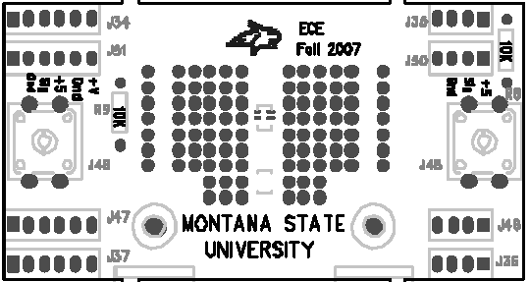
The bumper switches will be connected to the robot's main PCB during Lab #7. For now, temporarily attach the two right-angle brackets to the back of the bumper board using two ¼" 6-32 screws inserted through the front of the board and into the threaded hole in the bracket and just lightly tighten. Place the other 6-32 screws in the bottom of the bracket, also just lightly snug, for later use.
8
(screw in front, bracket on the back)

This completes the bumper switch PCB assembly. Good job!

