CRAFTING THE IDEAL PHYSICS CLASSROOM

by

Cal Wilkens

A professional paper submitted in partial fulfillment

of the requirements for the degree

of

Master of Science

in

Science Education

MONTANA STATE UNIVERSITY

Bozeman, Montana

July 2024

# ©COPYRIGHT

by

Cal David Wilkens

2024

All Rights Reserved

# ACKNOWLEDGEMENTS

I would like to thank my wife, Lizzy, and the rest of my family and friends for sticking by my side in what has been, at times, an arduous and stressful process in the acquisition of this degree. My time in this program is something I will always look back fondly on because this is where I learned many of the skills I needed to be a competent and caring educator. I also would like to thank John Graves and Kenneth Taylor for painstakingly going through every single rendition of my paper and endlessly discussing with me how to better it. A special thanks to John, who gave me the opportunity to stay in the MSSE program even though I was no longer able to teach in a classroom and worked with me every step of the way to ensure that I was crafting a meaningful capstone paper that related to my eventual first year in the classroom. Lastly, I would also like to thank my various physics professors over the years, namely Gail Welsh, who showed me that educators can be both incredibly intelligent, but also competent individuals who care about their students deeply.

# TABLE OF CONTENTS

1. INTRODUCTION AND BACKGROUND 1

Context of the Study 1

Focus Question 3

2. CONCEPTUAL FRAMEWORK 4

Applications of Technology 4

Disparity Between Genders 5

Peer-to-Peer Engagement 6

Kinesthetic Learning 8

Active Learning 9

Storylines 11

3. INSTRUCTIONAL STRATEGIES 14

Thoughts Behind Conceptual Framework 14

A Proposed Ideal Active Learning Classroom: The Kinematics Storyline 16

4. PROFESSIONAL REFLECTION 31

Guidance for Implementation 31

Professional Development 34

REFERENCES CITED 35

APPENDICES 38

APPENDIX A: Kinematics Storyline Template 39

APPENDIX B: Vectors Lesson 49

APPENDIX C: Approximate Analogies Coordinate Systems Worksheet 54

APPENDIX D: Graphing Uniform Motion Lesson 56

APPENDIX E: Graphing Nonuniform Motion Lesson 61

APPENDIX F: Graphing Nonuniform Worksheet 66

APPENDIX G: Kinematics Equations and Graphs 68

APPENDIX H: Freefall Lesson 70

APPENDIX I: Projectile Motion Lesson 75

# LIST OF FIGURES

Figure Page

1. Screenshot of YouTube Video Demonstrating Projectile Motion 17

2. Storyline – Kinematic Tools from 5E Lessons 18

3. Example Paths 19

4. Balls Moving at Constant Speed 21

5. Example Ramps 22

6. Example Scenario with Uniform and Nonuniform Motion 24

7. PHET Simulation Screenshot 28

8. Example of Projectile Motion Target 29

# ABSTRACT

The purpose of this study was to propose a methodology of teaching that incorporated inquiry teaching strategies in the classroom with the intent of transforming the classroom into an active learning environment. The most effective and feasible method for this was to create a storyline unit lesson plan for the first unit in a high school physics classroom, kinematics. In the storyline, students aimed for an ultimate goal of creating or obtaining a projectile launcher and used that launcher to hit a target somewhere above the ground. In order to do this, students created a toolbox of various tools. These tools were the various kinematics concepts they learned throughout the unit, like trigonometric functions, derivatives, velocity versus speed, and so on.

# CHAPTER ONE

# INTRODUCTION AND BACKGROUND

## Context of the Study

My first, and only, foray into the world of education took place at Montana State University in Bozeman, Montana. Over the span of two years, I worked as a graduate teaching assistant for entry-level physics courses. During this time period, I discovered that my passion for teaching far outweighed my interest in obtaining a Ph.D. in physics. Although I was only instructing labs, I found myself enjoying my time on campus the most when I was helping students understand concepts they struggled with. I, too, struggled with these concepts as an undergraduate, but now my new challenge was learning how to explain these concepts to people who had no prior knowledge or experience working with these ideas. Seeing my students succeed in the lab sections and subsequently in their lecture sections gave me a great sense of accomplishment. After one year in the Ph.D. program, I decided my goal was to become a full-time educator and transferred to the MSSE program.

Throughout my time as both a physics student and instructor, I have seen students express the sentiment that physics is a boring course. When students decide that they dislike a course they tend to lose focus and attend class less frequently. As a result, these students experience a drop in both their grades and understanding of the material (University of Pittsburgh at Johnstown, 1990). Losing focus like that can be particularly devastating for a student. Failing a course almost always forces the student to retake it, and, in the case of university, students pay more money. Such setbacks may decrease the likelihood of the student obtaining a degree. One of my primary goals is to make any classroom I teach in a setting where students feel engaged with the course material. Ideally, it will be a classroom where all students are not only invested in learning but also feel safe to share their feelings with not only me, but their peers as well. From my experience as a lab instructor, I find that when students feel comfortable in their surroundings they ask questions far more frequently. More engagement, along with having a sense of belonging, will inevitably lead to a deeper understanding of course material.

In the many lab sections I instructed, I always emphasized the need to ask questions. I made sure to let students know that no matter the issue, I would attempt, to the best of my ability, to help them overcome it. However, I also encouraged them to ask their peers for assistance. I explained that true mastery comes from the ability to clearly, and succinctly, explain a difficult concept to others. The action of explaining a tough conceptual idea to their peers allowed my students to not only pick out their own misunderstandings, but also furthered their understanding of the material to a level that they would likely not reach otherwise. If my students could do that, then they would have all the required skills to do well on homework assignments and exams. Some of the lab assignments did not have any hands-on activities, making them glorified worksheets, and thus encouraging little to no peer-to-peer engagement. The best activities, the ones that encouraged non-stop peer-to-peer engagement, were those that had multiple stations and presented a complex idea that required students to expand upon their knowledge from the lecture. Those in-depth, conceptually complex lab activities helped students acquire a much deeper understanding of the course material than any worksheet could have. The focus on peer-to-peer engagement, and intellectually stimulating lab activities, is something I will implement any time I instruct a course.

Currently, I do not have a job as an educator in a classroom, and therefore have no way to implement a traditional action research project without the study feeling incredibly contrived. I joined the MSSE program to acquire the necessary skills to become a competent and impactful educator. Using the information and concepts I learn throughout this program, and particularly those I research during this capstone project, I plan to craft my ideal, hypothetical classroom. With all that I have learned, I hope to teach physics courses at the high school level in the Denver, Colorado area. Ultimately, I want to apply what I have researched and formulated in my capstone to the actual classroom in which I will eventually teach. These goals led me to the formulation of this study.

## Focus Question

My focus question was, How can I use inquiry teaching strategies to create an in-depth, active learning environment in the classroom?

# CHAPTER TWO

# CONCEPTUAL FRAMEWORK

## Applications of Technology

One important aspect of creating a learning environment where students are both engaged and entertained is using modern technology, like virtual reality (VR). The goal of using such technology is to take an otherwise nebulous concept, like astrophysics, and allow students to see and interact with a physical representation of something they otherwise would not be able to. While utilizing VR at a science festival, patrons were able to manipulate stellar bodies and gravitational waves. Festival goers were surveyed and the majority of those interviewed claimed to be thoroughly engaged due to the immersive nature of VR. Visitors also felt engagement via facilitation, where experts in the field of astronomy guided the users through the VR world and answered any questions during the experience. These are objects and concepts that are normally considered complex, yet by using VR, people with no formal background in the subject area were enthralled and engaged by ideas that would otherwise cause them to disengage (Kersting et al., 2021).

Research shows that using educational video games in the classroom increases student engagement. An educational video game focusing on electromagnetism, which includes concepts like electromagnetic waves outside of the visible light spectrum, is an incredibly tough idea to visualize without the use of technology. There can be a disconnect between what students perceive to be relevant to their lives and what is relevant in a physics classroom. An educational video game can bridge that gap by allowing interaction with abstract concepts. Although video games can be helpful, students may not immediately understand how to use the game mechanisms. In this study, teams of students played through six levels of an educational video game. The six levels of the game were completed in intervals referred to as play-cycles, where one or two levels were completed per cycle. One team needed to use their first play-cycle to familiarize themselves with the controls and nuances of the game. However, once the controls were learned, the students were able to seamlessly use them in future play-cycles. In particular, when learning about electric fields in one of the latter parts of the first play-cycle, the students were able to manipulate the game mechanics so that they could move particles around in a direction of their choosing (Zuiker & Anderson, 2021).

In a study of 1034 undergraduate students in physics, biology, and chemistry courses, positive reception was found when educators employed the use of computer simulations in their classrooms. Simulations were used to teach projectile motion in the physics classroom. Surveys indicated that by using computer simulations, students felt more engaged and satisfied with the classes they were taking. This study does not go on to see if students retained the information, but the author believes that due to the strong emotional response students were observed to have regarding using computer simulation, hopes are high. Another important aspect of the study is that these simulations were used to augment students’ academic work not completely replace them (Almasri, 2022).

## Disparity Between Genders

When looking at gender in the physics classroom, it is important to recognize that, commonly, female students feel less comfortable than their male counterparts. This disparity in comfort level can lead female students to participate much less frequently than the male students in the classroom (Farhangi, 2018). In fact, when interviewing female graduate students in a physics program, the interviewees implied that they would change the very essence of who they were in order to be accepted by their peers (Gonsalves, 2012). Another study concluded that male students are more likely to immediately jump into a hands-on lab activity when compared to female students due to differences in exposure to science-related items at a younger age (Hasse, 2008). A good way to combat this feeling of alienation is to assign projects that connect back to the students’ lives, or for educators to encourage all students to think of ways physics connects to their everyday lives outside of school (Farhangi, 2018).

The use of technology, particularly computer simulations, can help female students feel more engaged in the classroom. In a study of 1034 undergraduate students learning via computer simulation, it was found that female students felt higher levels of engagement and satisfaction when compared to male students. Physics students ranked both their engagement and satisfaction regarding the use of computer simulations on a scale of one to five. Female students, on average, ranked their engagement and satisfaction levels at 4.65 and 4.40 respectively, whereas male students ranked their average engagement and satisfaction levels at 3.11 and 2.99 respectively. This indicates that using computer simulations as a means of learning in the physics classroom helps immensely with engaging female students even if the male students have more neutral feelings (Almasri, 2022).

## Peer-to-Peer Engagement

Engagement between peers in the classroom is not only important to help students become active learners, but also to remain engaged with the course itself. Zoey, a college student, expressed the sentiment that peer-to-peer engagement was paramount to success. Without any peer-to-peer engagement, Zoey felt as if she were not part of a community. Without this sense of community, Zoey implied a lack of the “sense of being accountable among friends in the lectures, which would keep Zoey from distraction or sleep” (Farhangi, 2018, p. 627). Student engagement in the classroom must stem from students engaging with one another rather than the teacher forcing engagement. In the traditional classroom, teachers present information via lecturing and students passively absorb this information. The goal of increasing student engagement begins with students transitioning into active learners. For a student to become an active learner teachers must transition to the role of a guide while students take more initiative in their studies. In a study of 400 10th- and 11th-grade students learning optics, it was observed that the majority of the students’ time in the classroom was spent listening to a teacher lecture. The authors of the study recommended that to increase student engagement, teachers should allow extra time for students to interact with one another and discuss the newly learned content (Ndihokubwayo et al., 2022).

In a study where researchers used technology at a science festival, peer-to-peer engagement was one of the ideas measured to understand how effective VR is in engaging the public with abstract concepts like astrophysics. The authors reflected upon peer-to-peer engagement in their section about collaboration. Some festival-goers took on the role of facilitator and posed questions to others in their group and guided them in a certain direction within the virtual world. Others would do their own separate activities but talk to the people in their group about what they were seeing, thus inspiring the group members to seek out similar observations. Intergroup discussion took place when VR headsets were passed on from one group to another. Patrons would tell those next-in-line what interesting phenomena they observed in the hopes the next users would seek those phenomena out. Peer-to-peer engagement allowed the participants to become active learners (Kersting et al., 2021).

When utilizing an educational video game about electromagnetism, students took on the role of an active learner. These students played through a level of the video game and then discussed the level and solutions for how to complete it as a group. After discussion within the group, students then joined the entire class for a large discussion. In a setting like this, peer-to-peer engagement is at the forefront, which allows the teacher to take a step back and act as the guide. Engagement was twofold in this setting. Students were learning the rules and controls of the video game and thus were forced to interact with one another to learn not only how to operate the game, but to think critically and complete the educational tasks put before them using the game mechanics. This setting encourages peer-to-peer engagement naturally instead of the educator forcing it directly themselves (Zuiker & Anderson, 2021).

## Kinesthetic Learning

Kinesthetic learning is where students learn via a hands-on approach. They physically interact with something in their environment by themselves or within a group setting. Generally, kinesthetic learning is one of three types of sensory learning methods: visual, auditory, and kinesthetic (Fleming, 2001). A simple regression analysis of data collected from nearly 1000 college students showed that kinesthetic learning has the largest influence on student engagement among the three types of sensory learning methods. Visual and auditory learning had smaller positive effects on student engagement as well (Almasri, 2022).

Hands-on learning can be any activity done in a laboratory setting. One study examines a group of 16 students who worked on two experiments revolving around linear motion. The first experiment that the students conducted involved using a stopwatch to measure the time intervals of a miniature train in motion. In the second experiment, students used a motion sensor and a sloped board to measure the train’s velocity and acceleration in a computer program called Logger Pro. After the final experiment, students expressed that the addition of physically seeing and interacting with materials in order to learn linear motion enhanced their understanding of the concept (Panuluh et al., 2020).

Even in a setting where one cannot physically touch something, like virtual reality, there can be a sense of pseudo-kinesthetic learning. Many patrons of the science festival, where VR was used to explore stellar objects, expressed that the ability to feel like they were physically present and floating by these untouchable objects was incredibly engaging. Some of the visitors explained how it would have been helpful if they could have seen their hands in the virtual landscape. This implies that while there is no literal physical interaction, VR has the ability to completely immerse a student in an abstract world by allowing virtual interaction controlled by the person’s bodily actions. Complete immersion in anything inevitably leads to increased engagement, whether the scenario in question is within a classroom or not (Kersting et al., 2021).

## Active Learning

Large undergraduate physics courses, with upwards of 300 students, generally tend to convey information in the form of a lecture. Lecturing leads to decreased student engagement as the semester goes on. To retain student engagement throughout the semester, professors need to adapt to a new method of teaching: student-centered active learning. In one study, two professors crafted the curriculum in their classrooms to focus on student-centered active learning. In the classes, students were expected to take the helm and engage in in-class discussions. Before class, students read about concepts that would have otherwise been talked about in lecture. After the readings, students took a short quiz. The professors skimmed through the quiz responses and picked out any misconceptions. To encourage class discussion, the professors showed slides in class that included anonymous answers highlighting the students’ misconceptions and asked them to discuss why, or why not, they believed the misconceptions to be incorrect. To see how effective the change in teaching methodology was, pre- and post-instruction tests were given to students in both classes. On the pre-tests, students in the class achieved a median score of 17 out of 30. The researchers then split the class into two groups: scores higher than 17 out of 30 and scores equal to or lower than 17 out of 30. When comparing the post-tests to the pre-tests, the stronger portion of the class achieved a normalized mean gain of 72% versus the weaker portion of the class’s gain of 52%. However, these gains were significant compared to the pre- and post-test scores of a traditional, lecture-based classroom. The normalized mean gain for the traditional classroom is 23% (Drinkwater et al., 2014).

In a study conducted at the University of Arizona in 2013, two physics courses teaching identical introductory mechanics used different teaching methodologies. One classroom, with 258 students, was taught using the traditional lecture style, and the other classroom, with 217 students, was taught using a style focused on active learning. In order to improve the students’ conceptual problem-solving skills, the professor in the active learning classroom used methods such as Think-Pair-Share and Ranking Tasks. These methods, along with once-a-week recitation sessions where students worked in groups to solve a quantitative problem, proved to be the more efficient teaching methods when compared to a traditional lecture style classroom. All students in both sections of the course took the same four exams which were based on the same content. When comparing the exam scores of the two sections, students in both classes performed around the same on exam one, but after, when the content surpassed what students generally learn in high school, the students in the active learning classroom began scoring higher on average. On the second exam, students in the active learning section scored 8.5% higher than their peers in the traditional learning section, and on exam three, students in the active learning section scored 7.5% higher. On the cumulative final exam, students in the active learning section scored 13.2% higher than their peers. The traditional learning section was taught by a renowned professor, lauded by students and teachers alike, however, the active learning section was taught by a first-time professor (Wallace et al., 2021).

## Storylines

One way of creating an active learning environment in the classroom is to utilize the instructional model known as storylines. Storylines allow students to become further engaged with the material presented compared to a traditional classroom where there is no hook for the students to follow throughout the entire unit. Students take command of their learning under this instructional method and use sense-making to figure out example phenomena. Their questions guide them from one lesson to the next. The first step in this process is to show the classroom an anchoring phenomenon. In one classroom, an educator, Mrs. T, uses a record-player to begin a discussion on sound waves. After witnessing the anchoring phenomenon, students discussed among themselves and tried to theorize about what was happening. This theorizing led to a driving questions board, from which Mrs. T took inspiration for their next step in the unit. Allowing students to come up with ideas about what confused them, or what they want to investigate further, allows for a deeper connection to the material and a sense of natural progression, or coherence. When a situation arises where students need further direction, the educator may push them in the right direction by encouraging discussion about a certain topic or idea within the unit. In Mrs. T’s classroom, they proposed the question of whether or not all objects vibrate to create sound. This question caused some disagreement in the classroom, but also created a healthy discussion between peers. Storylines aim to use phenomena to create a coherent flow of student exploration and discourse that eventually leads to a deep understanding of the content (Reiser et al., 2021).

In one anatomy and physiology classroom, an educator transformed a normal laboratory experiment about the integumentary system into a storyline activity in the hopes that students would be more engaged with the material. This task first began when the educator listed out learning goals for a unit, assigned a task to each learning goal, and designated a theme that outside of a storyline unit would not exist: a crime-scene investigation. Some evidence from the crime scene investigation included skin, a description of a rash, a fingerprint and hair. These pieces of evidence were compared to microscope slides of pigmented skin, non-pigmented skin, tattooed skin, pictures of different types of rashes, reference fingerprints and different types of animal hair. Before the lab, students learned about the integumentary system in lecture and completed pre-lab homework. This information was reinforced via a quiz given at the beginning of the lab. After completing the lab, students were surveyed in order to find out how they felt about the transformation of their normal lab into a storyline activity. Out of 132 students who participated in the storyline experiment, 86% reported that they felt more interested in the material than they would have without the storyline and 83% of the students reported a higher level of engagement with the material. Eighty-eight percent of students reported that due to the content of the storyline activity they felt like they were better able to connect information about the integumentary system back to the outside world. A majority of the students, 63%, reported that the inclusion of the storyline activity allowed them to have a deeper understanding of the material, while 23% of students were neutral, reporting neither that the storyline helped or hindered their learning experience, and only 8% of students believed that the storyline actively hindered their learning. Including a storyline activity, whether it be for an entire unit or only a single lesson, has been proven to increase student engagement with, and understanding of, the material (McDaniel, 2023).

# CHAPTER THREE

# INSTRUCTIONAL STRATEGIES

## Thoughts Behind Conceptual Framework

When I was researching particular concepts, I wanted to focus on activities or methodologies that would not only benefit my classroom, but also be feasibly implemented by an educator with minimal experience in the classroom. All research stemmed from the idea that I wanted to craft an ideal classroom where students are both actively involved in the learning process and where they feel comfortable participating in classroom activities. The idea to research particular teaching methodologies, such as utilizing simulations or kinesthetics in the classroom, stemmed from my practical experience as a graduate teaching assistant for physics laboratory sections. In those labs, students stated to me multiple times that doing these supplemental, hands-on activities significantly bolstered their understanding of the subjects they learned in lecture. I conducted the weekly laboratory experiments by telling the students that they needed to be in charge of carrying out the experiments, but that I would be available to answer any questions they had during that process. Students were expected to ask one another questions before coming to me. What I realized is that this was a classroom environment that used the idea of active learning and I wanted to apply that to my classroom in the future.

One of the main tenets of an active learning environment is that there is more to it than just lecturing students. I needed activities that would enthrall my students instead of boring them with countless traditional lectures. From experience in the laboratory sections of a traditional physics classroom I knew that hands-on activities, or kinesthetic activities, were conducive to increasing student engagement, and thus, an active learning environment. Relating what one learned in concept via formulas and definitions to real-world examples in the form of kinesthetic activities leads to deeper student understanding. However, in physics, not every concept is easily adapted into a kinesthetic learning activity. In the cases where kinesthetic learning cannot be applied in a reasonable or timely manner, one can move to use modern technology. The most relevant and practical use of modern technology in the classroom is computer simulation. Computer simulation allows students to interact with potentially tough-to-replicate phenomena and see how changing individual variables affects the physical situation in real time.

A classroom environment must be welcoming and inclusive, for any number of engaging activities utilizing kinesthetics or modern technology, to be successful. In STEM classrooms, particularly in physics classrooms, there is a pattern of female students not feeling as comfortable as their male peers which leads to lower participation in classroom activities. To combat this, I planned on finding activities that research showed to be able to combat the feelings of alienation female students felt in the classroom, such as computer simulations. Another aspect I had to consider when researching an all-inclusive active learning classroom environment was the idea of persistent peer-to-peer engagement. Not only does peer-to-peer engagement encourage inclusivity in the classroom, but in my laboratory sections, peer-to-peer engagement was paramount to my students succeeding. When students engaged one another and worked together to figure out the conceptually difficult problems they were presented with in lab, it led to the creation of an active learning environment where they were guiding their own learning, and I was simply facilitating it. In my own classroom, I planned to introduce a plethora of activities that leaned into the idea of group work, such as laboratory experiments that required multiple students to conduct.

## A Proposed Ideal Active Learning Classroom: The Kinematics Storyline

In my experience with entry-level physics courses, kinematics is the unit most commonly taught before delving into other concepts such as force, momentum, work, or conservation of energy. While other strategies like introducing the concept of forces first may work well, I am most comfortable with this approach. It allows for the easy introduction, or reintroduction, of mathematical concepts such as trigonometric rules, derivatives, integrals, and vectors. I do understand that this is a math-heavy unit to begin a physics course with, but a physics course, to me, will always inevitably be intertwined with mathematics. Giving students the tools they need to have a strong understanding of how closely physical concepts are interwoven with mathematical concepts is integral to their long-term success. To reach this goal, I have created a storyline unit lesson plan revolving around kinematics (Appendix A).

The storyline begins by showing students a YouTube video of a projectile launcher, where an object undergoes projectile motion (Figure 1) (Arbor Scientific, 2020). In an ideal world, I would create my own launcher, but for this storyline, a video will suffice. Projectile motion is the anchoring phenomenon because it highlights and utilizes the main goals of the kinematics unit. In this unit, students are expected to be able to apply concepts from calculus to physical scenarios that represent uniform and nonuniform motion, develop a model that explains the motion of an object in up to two dimensions, know the difference between scalar and vector quantities, and create position-time, velocity-time, and acceleration-time graphs that accurately depict the motion of an object. The educator will propose to students a plan where they introduce the tools needed to understand the mathematical and physical concepts behind projectile motion, with the ultimate goal of the students building their own projectile launcher and hitting a target. After each lesson, the educator will ask the students to write down the most important concepts and add them to a toolbox (Figure 2). They will use these tools when working on the final project of the lesson.

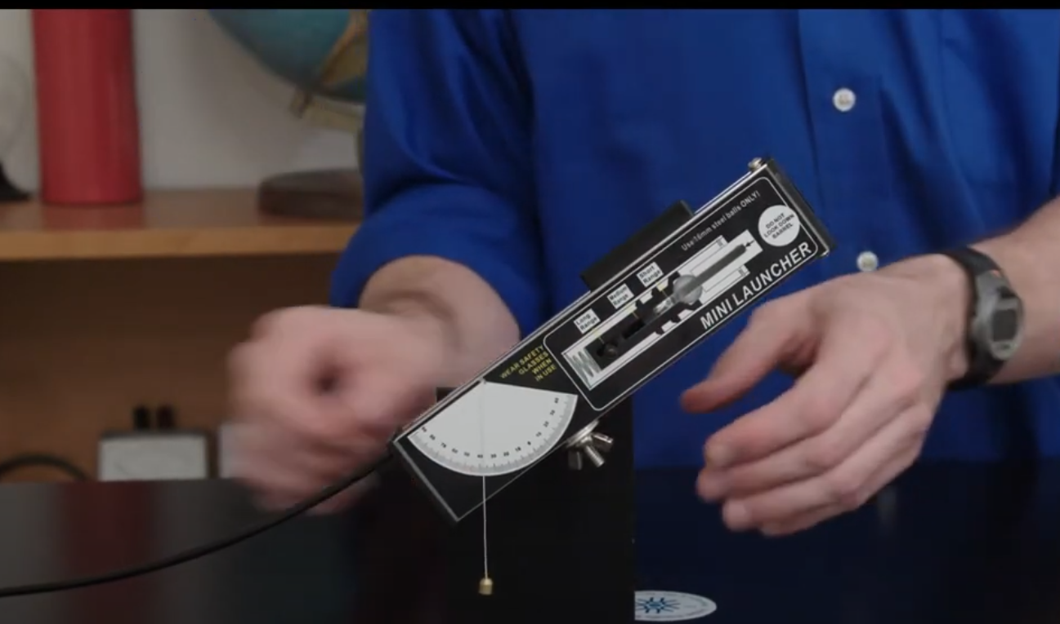

Figure 1. Picture of the Arbor Scientific YouTube video where an educator demonstrates how a projectile launcher works.

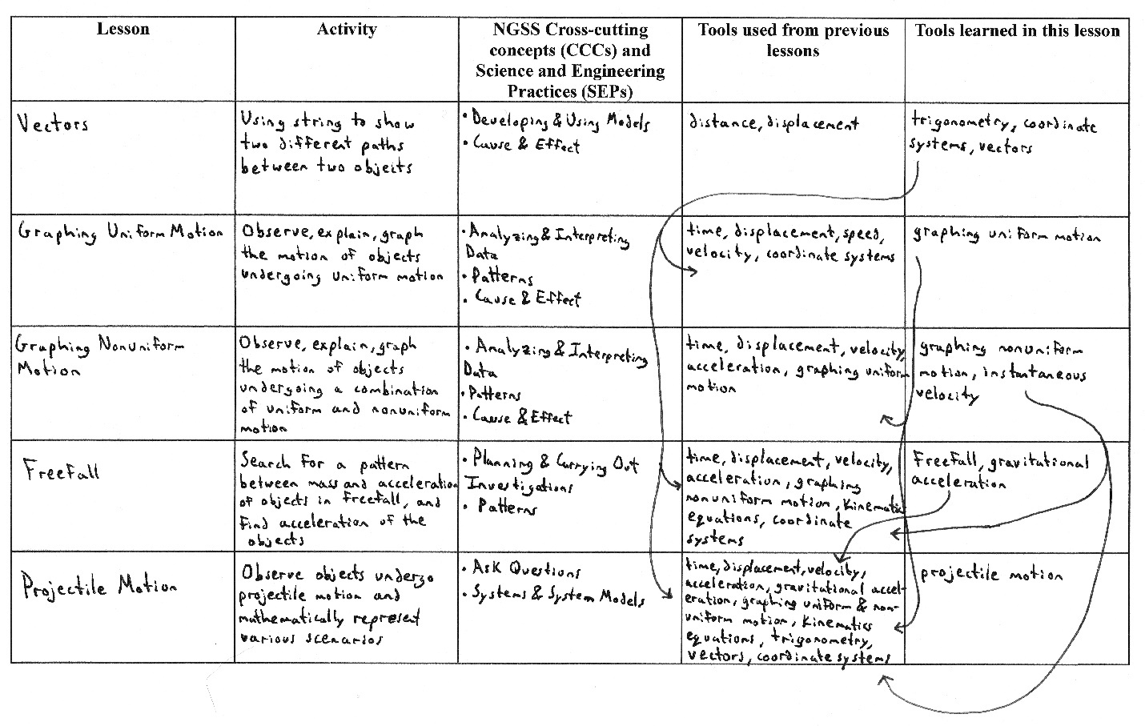

Figure 2. Kinematics storyline outline that details the five 5E lesson plans and what tools each lesson used from previous lessons and what tools are learned from the current lesson.

In the first lesson, students will observe an object move at different constant speeds. The educator performs a demonstration of what it means for an object to be at constant speed before the students break up into groups and interact with movable objects. Students will be introduced to the concepts of distance, displacement, and time intervals before breaking into groups. While interacting with objects, students are expected to take measurements of position and time and record their findings in a science notebook. Encourage students to move objects in opposite directions and ask them what they believe that implies. Educators should expect to see questions or statements on the difference in displacement during a given time interval for different constant speeds. At this point, students only have the bare minimum of tools to describe the physical scenario, but introducing these concepts slowly and methodically will lead to better student understanding by the end of the unit. After the lesson, to ensure the students understand the material, a Muddiest Point Classroom Assessment Technique (CAT) will be assigned (Angelo & Cross, 1993). Any questions the students have can be addressed during the next class period before moving on to the next lesson.

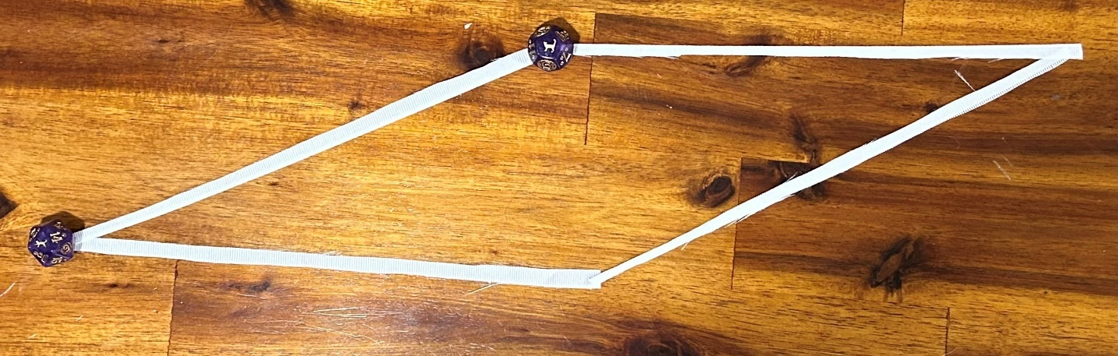

Figure 3. An example of different paths, created with ribbons, between two objects.

To really hammer home the difference between distance and displacement, introduce the concept of vectors and refresh students on trigonometry. Here, the educator is encouraged to incorporate real-life examples like the path someone takes on a hike or a track loop. The Vectors Lesson will have students use string to create physical representations of vectors (Figure 3) (Appendix B). The educator will begin by showing students that there are multiple paths one can take from the initial position of an object to its final position. Students should inquire about the difference between these paths and should recognize that while the paths may have different distances, the displacement is always the same. During the lesson, the educator will touch on how to find the number of degrees in an angle using trigonometric functions and how to define a Cartesian coordinate system and an origin point. To ensure students are engaged, they will break into groups and use strings to map out different paths between two physical locations in the classroom of their choosing. Students should create their own variation of the Cartesian coordinate system and define an origin point, calculate the degrees of any angle, and explain the differences between distance and displacement for any paths they create in their science notebooks. It is integral that students draw diagrams of what paths they create with the strings. Drawing diagrams that represent physical scenarios is a tool they will continue to use throughout their entire physics career. To ensure students understand Cartesian coordinate systems, knowledge required for understanding projectile motion, an Approximate Analogies CAT will be assigned (Angelo & Cross, 1993). At the top of this worksheet, students will be given two differently defined, Cartesian coordinate systems (Appendix C). They will be asked to relate the directions from one Cartesian coordinate system to the other. To take this concept further, they will also be asked to create their own variation of the Cartesian coordinate system and relate it to one of the given coordinate systems. Defining a coordinate system for a physical scenario is an invaluable skill to have.

With the definitions of distance and displacement, as well as the ability to define Cartesian coordinate systems, students should begin to ask how the negative directions on an x- and y-coordinate system relate to the movement of a physical object. For now, the educator should limit their examples to a single direction, the x-direction. Introducing the y-direction can come later, with freefall. In this lesson, the educator should begin by showing two objects moving at the same constant speed, but in different directions. This demonstration can segue into a discussion on the difference between speed and velocity, and scalar and vector quantities as a whole. Students, after the mini-lesson, should understand what it means for an object to have a negative velocity. The class can have an open discussion about thoughts and questions before they turn their attention to an Applications Card CAT (Angelo & Cross, 1993). Students will be asked to write about a scenario where an object moves back and forth and explain whether or not the object has a positive or negative velocity at different points in time. After, students will be encouraged to share their examples with the class on the board. Next, the educator will pose a dilemma to their students about an object with changing speed. A demonstration of a ball rolling down a ramp will be given. Another class discussion will take place about the differences between a ball rolling on a flat surface at constant speed versus a ball rolling down a ramp where its speed is increasing. The educator should give the formal definition of acceleration here and explain that what the students are observing is nonuniform motion. Again, students will be assigned an Applications Card CAT, where they write about a scenario that would cause an object to accelerate that they have witnessed in real life or can feasibly explain occurring in real life. The educator should ask students to think about what it means for an object to have negative acceleration. This will be covered later in this unit lesson plan, but having students begin to think about this concept early can only help their understanding later. Once completed, students will be asked to share their examples with the class so a class-wide discussion can take place.

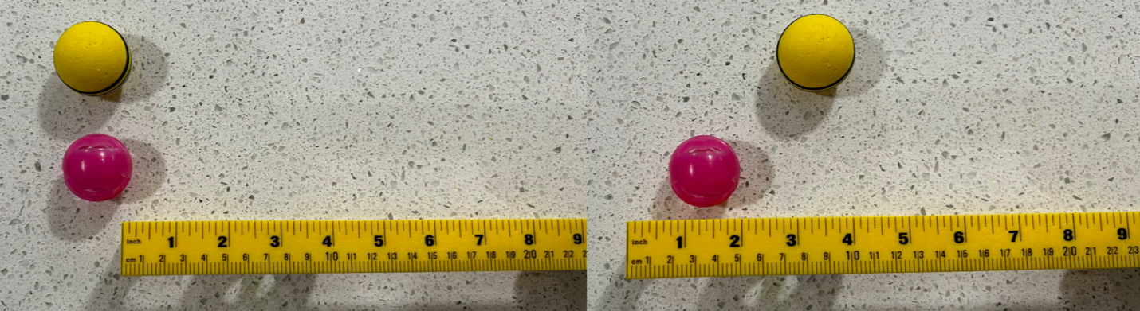

Figure 4. Balls moving at different constant speeds. The picture on the right shows the balls at $t=0s$ and the picture on the left shows the balls at $t=1s$.

The Graphing Uniform Motion Lesson will have students observe and explain many different scenarios that consist of a wide array of objects moving at varying constant speeds (Figure 4) (Appendix D). Here, the educator wants to introduce the concept of graphing motion via position-time and velocity-time graphs. Understanding how to accurately graph the motion of an object is the first step of many that leads to a deep understanding of projectile motion, and kinematics as a whole. A simple scenario where an object moves at a constant speed and how to represent it via position-time and velocity-time graphs should be demonstrated to the class. The educator should ask the students in the class to volunteer and build another, different physical scenario of an object moving at constant speed. Allow the students of the class to take the lead and instruct them to create another set of motion graphs, that focuses on a time interval not starting at zero seconds, on the board. After, students should break out into groups where each group creates position-time and velocity-time graphs based on preset scenarios at different stations, allowing time for students to swap between stations to make multiple sets of motion graphs in their science notebooks. Students will be asked to work on a Documented Problem Solutions CAT for a single scenario of their choosing (Angelo & Cross, 1993). In this assignment, students will explain, step-by-step, how and why they graphed the motion of an object on both a position-time and a velocity-time graph. Before beginning the next lesson, the educator should hold a class-wide discussion on any misconceptions students may have about graphing motion of objects undergoing uniform motion and leave the class wondering about how to graph nonuniform motion.



Figure 5. An example of homemade ramps at three different slope angles.

In the next lesson, students will observe nonuniform motion and communicate to their peers the differences in acceleration of objects rolling down ramps of various slope angles (Figure 5). The goal here is to get students to understand the difference in magnitude of constant acceleration due to the different slope angles. In the future, students will understand that a greater slope angle equates to a greater magnitude of acceleration. A preset Cartesian coordinate system will be written on the whiteboard, or wherever all students can conveniently see it. The educator will instruct students to break out into their lab groups and go to particular stations where a scenario involving a ball undergoing nonuniform motion is set up. At each station, students will be expected to take measurements, calculate the acceleration of the ball, and explain whether the acceleration was positive or negative based on the given coordinate system. After each group has measured and calculated the magnitude and direction of acceleration, the class will reconvene and rank the relative magnitudes of acceleration for each scenario on the whiteboard. At this point, the educator can discuss the difference between positive and negative acceleration, and how an object can have a positive velocity and a negative acceleration, or vice versa. Another concept to touch upon here is average velocity. The educator can explain that average velocity is useful, but that one must be careful when using this tool, especially in a scenario where an object undergoes various constant accelerations, such as a car speeding up for an amount of time and then slowing down. Ask the students how they believe they would approach such a situation from a mathematical standpoint. With the ideas of positive and negative velocity and acceleration fresh in their minds, the students will be assigned an Applications Card CAT (Angelo & Cross, 1993). For this Applications Card CAT, students will be asked to give real-life examples of an object with positive velocity experiencing negative acceleration and an object with negative velocity experiencing positive acceleration. These concepts can be confusing for students learning kinematics for the first time, so class discussion of any misconceptions the educator finds is of the utmost importance.

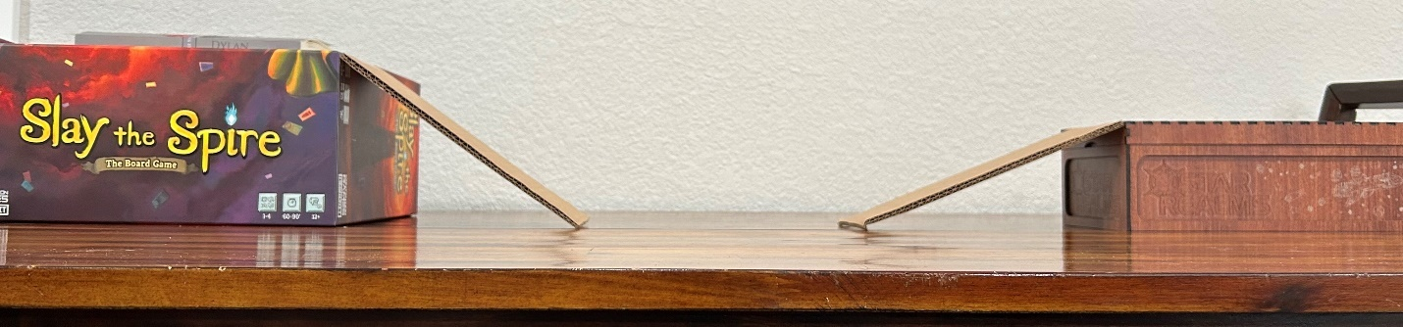

Figure 6. An example of a scenario where an object would undergo uniform and nonuniform motion.

Once the educator believes the class has a solid grasp of the fundamentals of displacement, velocity, and acceleration, they can transition into the Graphing Nonuniform Motion Lesson where the class plots the motion of objects undergoing both uniform and nonuniform motion via position-time, velocity-time, and acceleration-time graphs, and explains the motion of objects undergoing uniform and nonuniform motion from graphs of motion (Appendix E). Before the students break into groups and begin working on this, the educator will present a scenario where an object undergoes uniform and nonuniform motion and plots this scenario on position-time, velocity-time, and acceleration-time graphs (Figure 6). Students must understand the differences between plotting uniform motion versus nonuniform motion on the motion graphs. A mini-lesson that introduces instantaneous velocity and demonstrates how to find it on a position-time graph, as well as a refresher on average velocity and how to find it, will be given. At lab stations, there will be various scenarios that depict different combinations of uniform and nonuniform motion. Students will be expected to work within their groups, and accurately plot position-time, velocity-time, and acceleration-time graphs for each unique scenario in their science notebooks. After all groups finish the motion graphs at each station, a class-wide discussion can be held to answer any questions. Then, the students will be asked to return to their groups and return to a randomly selected station. This time, students will look at motion graphs placed at the stations and work together, using the materials provided, to recreate the scenario depicted by the motion graphs. It should be stressed that the ramps must be straight, not curved, otherwise the students will run into difficulties. The educator will visit each group periodically to answer questions, and when a group believes they have accurately recreated the physical scenario, will watch the students demonstrate and explain their work. To assess student understanding of the new concepts introduced in this portion of the unit, a homework worksheet will be given that asks students to plot motion graphs for a given scenario (Appendix F). A class-wide discussion will take place regarding any issues students had with the homework.

At this point in the unit, students will have experienced quite a bit of connecting physics concepts to mathematical concepts, but this next lesson will take that one step further. Here, the educator will introduce the kinematics equations that allow for a mathematical description of any scenario involving constant speed or acceleration, including projectile motion. This will be a stretch for some students, so the educator should take steps to ensure that students show proficiency in accurately plotting position-time, velocity-time, and acceleration-time graphs before beginning this lesson. Before the class can take this step, the educator must explain that the area under the curve, or the integral, of a velocity-time graph represents displacement. Once the class has a decent understanding of that concept, the educator will provide the kinematics equations, and the graphs that depict them (Appendix G). The class will discuss what they believe the graphs represent, and how the graphs allow us to derive the given kinematics equations. Here, the educator should expect confusion. Though some students may be confused, it is important to show how one arrives at the equations that will be used for the remainder of the unit. To show that these equations can be used for any scenario involving constant acceleration, the educator should use past examples and assign discrete values of displacement, velocity, time interval, and/or acceleration to each scenario. Students will be expected to use the kinematics equations to find different values in order to grow accustomed to using the equations for future, different scenarios. Going over this homework with the class before moving to the next lesson, freefall, is essential to the students’ continued understanding of the kinematics equations.

Up to this point, students have largely worked with scenarios where objects move in a single direction, commonly the x-direction. In the Freefall Lesson, students will now work with the y-direction, where observations will be made of objects that are dropped and allowed to fall to the ground, or in other words, they will be observing freefall. Students will be expected to plan and carry out an investigation into freefall and search for a pattern between mass and acceleration (Appendix H). The final goal of this investigation is to have students understand that, in the absence of air resistance, a condition that will always be assumed for this unit, all falling objects undergo the same rate of acceleration: the acceleration of gravity. Understanding this is a key tenet of understanding projectile motion, where all objects also experience the same rate of acceleration: gravitational acceleration. Students will be instructed to break into groups, where each group has access to objects of varying mass. In their science notebooks, students will record their measurements and observations in their quest to determine the acceleration of the falling objects and make graphs of motion that accurately depict freefall. Students are encouraged to use kinematics equations to figure out the value for acceleration. After each group has determined a value for acceleration, a representative from each group will come up to the whiteboard to write down their final acceleration value. The class will discuss these findings and rectify any discrepancies. Ideally, the groups will all be able to determine that the acceleration of these objects is roughly $10\frac{m}{s^{2}}$, the commonly accepted value of the rate of gravitational acceleration on Earth. The educator should pose a question about mass and if that affects the rate of acceleration. Allow the class to discuss. To emphasize the point that objects in freefall all experience the same rate of acceleration, ask students to take a video of two objects, released from the same height, falling to the ground. If, for some reason, a student sees that the two objects do not experience the same acceleration, ask them to try and explain why. There is no need to delve into great detail here, but it is useful to have the students begin to think about forces at this point in the unit. At the beginning of the next class period, ask if any students would like to share the videos they made. The educator should allow for any final questions on freefall before moving to the final portion of the unit: projectile motion.

With all the required tools in their toolboxes students are now ready to tackle the Projectile Motion Lesson. Before students are asked to make or obtain their own projectile launchers and hit a predesigned target, they must first familiarize themselves and have a deep understanding of how to explain the motion of objects undergoing projectile motion. Because students have all the tools they need for this lesson, they will immediately break into groups and visit lab stations with various examples of projectile motion (Appendix I). Using the given and measured variables at each station, students will solve for the requested quantities of displacement in the x- or y-direction, time, initial velocity in the x- or y-direction, and/or final velocity in the x- or y-direction. During this exercise, the educator should walk around and be in constant communication with each group, ensuring that they know what they should be doing. After checking to make sure each group has the correct values, the students will be asked to plot position-time, velocity-time, and acceleration-time graphs for both the x- and y-directions for a single projectile motion scenario. After, the educator can, once again, check with each group to ensure they are arriving at the correct answers.

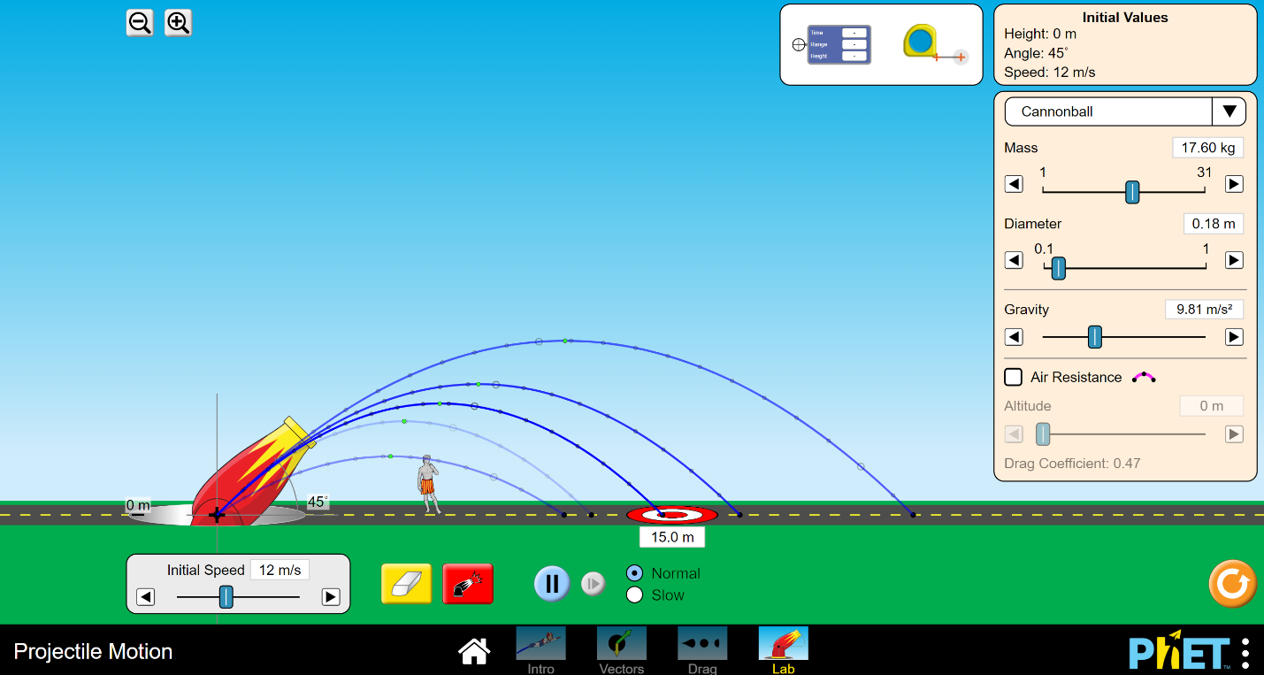

Figure 7. A screenshot of the PhET simulation, showing the trajectory of projectiles attempting to hit a target on the ground.

Before leaving class, the educator will show the students how to use the projectile motion PhET simulation (Figure 7) (PhET, 2022). For homework, the students will be assigned a Documented Problem Solutions CAT, with a bit of a twist (Angelo & Cross, 1993). Students will be tasked with creating a projectile motion scenario using the PhET simulation and coming up with questions that ask about a variable of their choice related to the scenario. They will pretend as if they are the instructor and ask questions to their hypothetical students. As part of this assignment, they need to provide a detailed solution to the question they crafted along with position-time, velocity-time, and acceleration-time graphs that accurately depict the motion of the projectile in both the x- and y-directions. During the next class period, the educator will collect their work and check it over before handing it back to students the next day and instructing to students to swap their work with another random student in the class. This will allow the students to complete questions crafted by other students. Once completed, the students will show one another their work and explain what they did correctly or incorrectly. Throughout this exercise, the educator should be walking around to ensure the activity is proceeding smoothly.

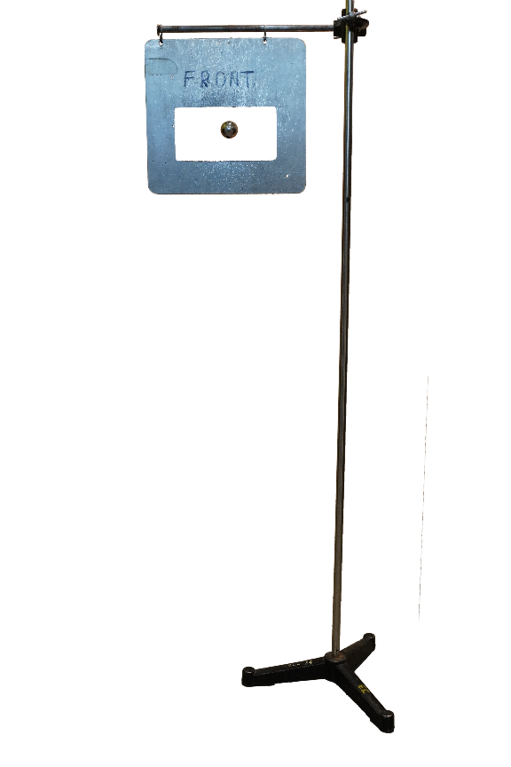

Figure 8. Example of a target for the projectile motion exercise.

If everything goes well, and the students have a solid understanding of the mathematics behind projectile motion, they can move on to the final exercise of the unit. Students will break into their lab groups and will be asked to brainstorm a way to either craft a projectile launcher or use something in their homes as one, as long as they can feasibly take the needed measurements that allow for the prediction of movement. The educator should make sure to approve each crafted or obtained item before the students move forward with their ideas. The goal for this lesson is to both craft and/or obtain a projectile launcher, and accurately predict motion such that the projectile can hit a predesigned target (Figure 8). Students displaying that they can accurately predict motion includes the plotting of position-time, velocity-time, and acceleration-time graphs for both the x- and y-directions in their final lab write-ups. Throughout this experiment, students will be expected to detail and explain the steps of their procedure in their science notebooks. For each step of the procedure, students will be expected to explain what tools they need from their toolboxes. While this experiment, and subsequent lab report, will be a lot of work, the students should have a good time during the actual experiment. It should be challenging and inspire them to use critical thinking. After each group has successfully hit their target, they should be ready to give a demonstration to the rest of the class that talks about their projectile launcher, what measurements they had to make to hit their target, and any difficulties they experienced along the way. Finally, each student should make a formal lab report detailing their work on this project. A final class discussion about any underlying or lingering questions should occur after all students receive their lab reports back, with an emphasis on why all the objects fall at the rate of gravitational acceleration. This emphasis will provide a perfect transition to the next unit in an entry-level physics course: forces.

# CHAPTER FOUR

# PROFESSIONAL REFLECTION

## Guidance for Implementation

Before using this storyline unit lesson plan, you must ask yourself if your students have the required background in mathematics, namely calculus. Students should either be currently taking or have taken a calculus class for you to get the most out of this lesson plan. While it would be possible to teach students about derivatives and integrals, and how to relate those ideas to plotting functions on graphs of motion, students having prior knowledge of the subjects cuts down the time needed to teach this unit by nearly half. For the students, these mathematical concepts should be something they know of, but are rusty with using at worst. However, they still will be a bit overwhelmed with the number of mathematical concepts that will be thrown at them in the first two or three weeks of the unit. Vectors and angles in particular are a bit of an oddity in the sense that they learn them early on, but do not work in two-dimensions until they reach the end of the unit and work with projectile motion. Mathematics is an intrinsic part of physics, where many of the problems you and your students will work on are essentially applied mathematics problems.

I keep harping on mathematics, but for an introductory high school physics unit, that is the only area of study I would expect my students to have somewhat of a background in. Now, for what comes after, forces, I think that the idea of forces should be sprinkled into the lessons that take place later in the unit. How in-depth you go with forces before formally starting the unit is up to you. I prefer to only touch upon them when getting to freefall but introducing them as early as the lesson on nonuniform motion can work perfectly well. As long as students understand the importance of vectors, vector components in two dimensions, and drawing diagrams, they will be set up for success in future units. I imagine any unit on forces would involve a copious number of free-body diagrams, so getting students in the habit of drawing out a representation of the physical system is of the utmost importance and is why I constantly mention their science notebooks in my lesson plans.

When it comes to their science notebooks, I believe it pays to be somewhat organized, but pressuring students too much to adhere to incredibly strict standards will make them shy away from wanting to use their science notebooks at all. Having a resource where they can go back and look at the solutions to many difficult problems from throughout the unit will be helpful for the rest of the school year. There will always come a time when a student forgets how a concept from earlier in the year works, and having a detailed science notebook can alleviate that problem.

As far as the problems the students will be working on, I do not believe that assigning impossibly difficult problems that the students get graded on is a great way of judging student ability. I believe that educators should absolutely assign difficult, thought-provoking problems. However, those problems should be assigned in a setting where the students know that their grades will not be penalized for getting those questions wrong, but where they are still encouraged to try their hardest when solving those problems. A good place for difficult questions is a homework assignment that is graded based on whether or not the student genuinely tried to complete it with the caveat that if they did something incorrectly, they would make corrections and explain what they needed to correct. I believe in giving students multiple chances to correct their wrong answers, whether it be on homework or an exam, but they must show a willingness to put in the work to understand the concepts being taught. The goal, after all, is to share the knowledge you know with your students in such a way that leaves them with a lifetime understanding of that knowledge.

If an educator were to choose to expand upon this lesson plan, I believe that going more in-depth with every single lesson outlined in the storyline would allow for a better idea of how long the unit would take to teach. I also believe that incorporating more simulations could be beneficial, but I would want to implement this storyline in a classroom before changing anything about it. It is also completely possible that I have misjudged how long it will take for students to understand certain topics and will need to readjust my expectations in future school years. I think it is more likely than not that this storyline will change drastically after I implement it in the classroom for the first time next year. Maybe the students do not jive with the idea of kinematics tools and creating a toolbox. Maybe they will love it and I choose to lean further into that idea. In fact, many times throughout the unit lesson plan I describe concepts that the students should understand, but if they do not, it is not the end of the world. I believe it will be the norm to adjust the lesson plan on a class-by-class basis, as no two classes will ever be the same. If students are struggling with content, perhaps spend a bit more time on that particular lesson or adjust it as you see fit. It is impossible to tell how well a lesson plan works when it has never been put into practice, but an idea of what you will teach and how you will teach it is better than no idea at all.

## Professional Development

It is hard to say if I changed as a practitioner during the writing of this paper and creation of the kinematics storyline. I have yet to lead a classroom, but that will soon change when I begin teaching next year. What I can say for sure is that I have a deeper understanding of what it means to create an in-depth unit lesson plan that I would willingly implement in my classroom. It is an incredibly lengthy process, lengthier than I imagined, but the effort behind it has meaning. Going into my first year of teaching, I would like to either create my own unit lesson plans for the entire year or adapt plans others have written to have at least a baseline plan I can refer back to when I get overwhelmed. Either way, I will be working on creating a year-long lesson plan that will guide my path when I begin teaching next year.

When creating this unit lesson plan, I realized the importance of seamlessly transitioning between different units. I think connecting what the students are currently learning back to something they learned in the past, or something that they will learn in the future is a great way of retaining past knowledge or allowing for callbacks to the current unit in the future when students are learning something new. Physics in particular has many of these callbacks, whether it be calculus and trigonometry at all times, kinematics equations in the unit on forces, forces in the unit on momentum, forces in the unit on work and energy, or even recalling gravitational force in the unit on electrostatic forces. What you learn in physics never truly goes away, so connecting the concepts that students are learning back to concepts they already learned is important. I will work tirelessly on creating, and adjusting, my lesson plans so that my future students have the best learning experiences possible.

# REFERENCES CITED

Almasri, F. (2022). Simulations to teach science subjects: Connections among students' engagement, self-confidence, satisfaction, and learning styles. *Education and Information Technologies*, *27*(5), 7161-7181. <http://dx.doi.org.proxybz.lib.montana.edu/10.1007/s10639-022-10940-w>

Angelo, T. A., & Cross, K. P. (1993). *Classroom assessment techniques: A handbook for college teachers* (2nd ed). Jossey-Bass.

Arbor Scientific. (2020, June 2). *Mini projectile launcher | For projectile motion studies | Arbor Scientific* [Video]. YouTube. https://www.youtube.com/watch?v=LpFPWu_QLl0

Drinkwater, M., Gannaway, D., Sheppard, K., Davis, M., Wegener, M., Bowen, W., & Corney, J. (2014). Managing active learning processes in large first year physics classes: The advantages of an integrated approach. *Teaching & Learning Inquiry*, *2*(2), 75–90. https://doi.org/10.20343/teachlearninqu.2.2.75.

Farhangi, S. (2018). Contribution to activity: A lens for understanding students' potential and agency in physics education. *Cultural Studies of Science Education, 13*(3), 617–637. http://dx.doi.org.proxybz.lib.montana.edu/10.1007/s11422-016-9792-y

Fleming, N. (2001). *Teaching and learning styles: VARK strategies*. Neil D. Fleming.

Gonsalves, A. (2012). Physics and the girly girl—There is a contradiction somewhere: Doctoral students’ positioning around discourses of gender and competence in physics. *Cultural Studies of Science Education, 9*, 503-521. https://doi-org.proxybz.lib.montana.edu/10.1007/s11422-012-9447-6

Hasse, C. (2008). Learning and transition in a culture of playful physicists. *European Journal of Psychology of Education*, *23*(2), 149–164. https://doi.org/10.1007/BF03172742

Kersting, M., Steier, R., & Venville, G. (2021). Exploring participant engagement during an astrophysics virtual reality experience at a science festival. *International Journal of Science Education*, *11*(1), 17–34. <http://dx.doi.org.proxybz.lib.montana.edu/10.1080/21548455.2020.1857458>

Malcolm, L. (1990). *Class attendance in undergraduate classes: Why and when do students miss classes?* University of Pittsburgh at Johnstown. <http://search.ebscohost.com.proxybz.lib.montana.edu/login.aspx?direct=true&db=eric&AN=ED318344&site=ehost-live>

McDaniel, K. (2023). “Worst Thief Ever”- The Use of a Storyline to Engage Students in a Traditional Hands-on Lab Experience. *Human Anatomy and Physiology Society Educator*, *27*(1), 53-68. https://doi.org/10.21692/haps.2023.007

McDermott, L. C. (1996). *Physics by inquiry volume 1*. John Wiley & Sons, Inc.

Ndihokubwayo, K., Uwamahoro, J., & Ndayambaje, I. (2022). Assessment of Rwandan physics students' active learning environments: Classroom observations. *Physics Education*, *57*(4). https://doi-org.proxybz.lib.montana.edu/10.1088/1361-6552/ac69a2

Panuluh, A., Elisabeth, D., & Yosep, D. (2020). Physics education students’ perception on the use of motion detector in linear motion practicum.*Journal of Physics: Conference Series, 1470*(1). https://doi.org/10.1088/1742-6596/1470/1/012087

PhET. (2002). *Projectile motion*. PhET Interactive Simulations. https://phet.colorado.edu/en/simulations/projectile-motion

Reiser, B., Novak, M., McGill, T., & Penuel, W. (2021). Storyline Units: An Instructional Model to Support Coherence from the Students’ Perspective. *Journal of Science Teacher Education,* *32*(7), 805-829. <https://doi.org/10.1080/1046560X.2021.1884784>

Wallace, C., Prather, E., Milsom, J., Johns, K., & Manne, S. (2021). Students taught by a first-time instructor using active-learning teaching strategies outperform students taught by a highly-regarded traditional instructor. *National Science Teachers Association*, *50*(4), 48–57. https://www.nsta.org/journal-college-science-teaching/journal-college-science-teaching-marchapril-2021/students-taught

Zuiker, S., & Anderson, K. (2021). Fostering Peer Dialogic Engagement in Science Classrooms with an Educational Videogame. *Research in Science Eduation*, *51*, 865–889. <http://dx.doi.org.proxybz.lib.montana.edu/10.1007/s11165-019-9842-z>

# APPENDICES

APPENDIX A

# KINEMATICS STORYLINE TEMPLATE

APPENDIX B

# VECTORS LESSON

|  |
| --- |
| VECTORS LESSON PLAN |
| Unit Topic: Kinematics  Lesson Science Content: Vectors, coordinate systems, distance, displacement  Length: 55 minutes  Performance Expectation: Students will construct a model to demonstrate how the different paths an object can take to get from its initial position to its final position can produce different values for distance, but not displacement.  Materials Needed:  Teacher: String  Student Materials: String  Background: Learning about how to define a Cartesian coordinate system and how to redefine it is important in understanding two-dimensional motion but is just generally a skill all physics students need to know well. Understanding vectors and the trigonometric mathematics behind them will allow for seamless transition to future units where vectors are used, such as the unit on forces. Vectors and Cartesian coordinate systems are fundamentals needed to understand projectile motion, the ultimate goal of this unit.  NGSS DCI, SEPs & CCCs: Appendix A |

### Engage

Opening: This lesson is designed to introduce, or reintroduce, students to the idea of vectors, how to calculate the degrees in an angle created by vectors via trigonometric functions, coordinate systems, and how the three concepts are related. On the board, the educator will place two dots, one representing the initial position of an object and one representing the final position of an object. The educator will draw a single path between the initial and final position. They will ask the class the following questions (5 minutes).

1. What other paths can the object take from the initial position to the final position?
2. What is the difference between the distance and displacement of the paths, if any?
3. How can we measure the distance from the initial position to the final position?

Potential Observations: There can be an infinite number of paths, paths can go in any direction, as long as it starts at the initial position and ends at the final position, distance changes, but displacement does not.

Explanation of Problem: Students will likely conclude that the longer the path, the larger the distance. However, they should also realize that displacement is not affected by path length, only the initial and final position of the object.

### Explore

Ensure that students understand the difference between distance and displacement of a path with the same initial and final position. Once the students are familiar with the concept, introduce the concepts of vectors, vector components, trigonometric functions, and how to define coordinate systems with an origin point. Here, the students should learn about how to find the degrees in an angle formed by vectors, and what directions those vectors are in based on the given coordinate system (10 minutes).

Students should break into their lab groups and use string to physically create vectors that define a path from one physical point in the classroom to another. Ask that they make multiple paths between those same points. Students are expected to create their own Cartesian coordinate systems, or at least explain the orientation relative to their paths, define an origin point, calculate the degrees of angles in their paths, and explain the difference between distance and displacement in their science notebooks. All of this should be accompanied by a diagram of their path (20 minutes).

### Explain

On the whiteboard, explain how essential it is to be comfortable with defining your coordinate system and origin point for any given system. Ask groups to come up to the whiteboard and explain why they chose the coordinate system and origin point for their particular path. Students should also explain the path they chose, and what vectors were used to get from the initial position to the final position. Here, the educator should be sure to give a quick example of vectors and vector components, along with an angle calculation to ensure students understand how to find these items (10 minutes).

Closing: Ask students if there are any questions about what was learned in the lesson today and discuss with the class if there are. Give an example of a path with a defined coordinate system and ask the students to define the vector, vector components if any, and the angles of all vectors. They can work on this as a class, with the educator jumping in as needed (10 minutes).

### Evaluate

Students will be assigned an Approximate Analogies CAT based on coordinate systems (Angelo & Cross 1993). The intention here is to ensure that they have the ability to both interpret information from a defined coordinate system and define one themselves if necessary. On the homework worksheet, students will be given two coordinate systems: one with the cardinal directions and one with the x- and y-directions (Appendix C). They will be asked to relate the cardinal directions to the x- and y-directions. Then, they will be asked to create their own coordinate system and relate that back to one of the given coordinate systems. This is not meant to be a difficult exercise. It is meant to ensure the students have a solid understanding of coordinate systems.

### Extend

In the next lessons, students will be tasked with examining the differences between objects moving in different directions, at different constant speeds. The educator should ask students to represent the different directions and speeds with vectors, as well as asking students to explain what direction the objects are moving via interpretation of the given coordinate system. The educator can also ask students about the angle of the vectors, but objects moving at constant speed commonly move in the positive or negative x-direction, which correlates to angles of 0 or 180 degrees. Angles will be more important when calculating the initial and final velocity of objects undergoing projectile motion, so introducing these concepts early on is important to get students thinking about this early step to understanding kinematics, and thus projectile motion.

### Potential Misconceptions and Solutions

Students may struggle with how to define their vectors when working with a non-normal Cartesian coordinate system. A good way to alleviate this issue is to demonstrate an example on the white board where the educator defines their own non-normal Cartesian coordinate system and shows how to define vectors using that system, and then asking the students to do the same in their groups and discussing amongst their peers. Students may also struggle with calculating distance and displacement when the initial position is not located at the origin point. If this issue arises, allot a few minutes of time for a class discussion on how to handle this particular issue by providing examples on the board.

APPENDIX C

# APPROXIMATE ANALOGIES COORDINATE SYSTEMS WORKSHEET

APPENDIX D

# GRAPHING UNIFORM MOTION LESSON

|  |
| --- |
| GRAPHING UNIFORM MOTION LESSON PLAN |
| Unit Topic: Kinematics  Lesson Science Content: Position-time graphs, velocity-time graphs, uniform motion, constant speed  Length: 65 minutes  Performance Expectation: Students will observe and explain the motion of objects moving at different constant speeds and graphically represent those scenarios on position versus time graphs and velocity versus time graphs (cause and effect).  Materials Needed:  Teacher: Ball, large surface (empty lab table)  Student Materials: Ball, large surface, meter stick, time recording device  Background: Graphing uniform motion in one dimension is the first step to understanding and being able to make accurate motion graphs for an object undergoing projectile motion. Before students even get to projectile motion, they must first learn the kinematics equations, which are derived from velocity-time graphs.  NGSS DCI, SEPs & CCCs: Appendix A |

### Engage

Opening: This lesson is designed to introduce the concept of accurately graphing the motion of an object undergoing uniform motion via position-time and velocity-time graphs. The educator should have a short demonstration of a ball moving at a constant speed, taking the appropriate measurements. After writing down the measurements and defining a coordinate system on the board, the educator should pose the following questions to the class (5 minutes).

1. How do we use these measurements to plot a position-time graph?
2. How do we use these measurements to plot a velocity-time graph?
3. How do the two graphs relate?

Potential Observations: Use the displacement measurements for an easy, almost one-to-one plot for the position-time graph, need to find velocity from the displacement and time measurements, velocity-time graph will be a horizontal line, slope of the position-time graph is equal to the value of velocity on the velocity-time graph.

Explanation of Problem: The position-time graph is self-explanatory as the measurements should be on the board. The displayed function should be a straight line with a positive slope. The velocity-time graph requires the knowledge that displacement divided by time is equal to velocity, in other words, the slope of the position-time graph. The displayed function for that graph should be a horizontal line above the x-axis.

### Explore

Next, the educator should ask students to volunteer and create another scenario of a ball moving at a constant speed, but ensuring it is different from the initial demonstration. For the new scenario, students should take the lead, take measurements, and create position-time and velocity-time graphs on the board. Class discussion is encouraged throughout the process, with the educator offering help, but not leading the discussion. Once students have accurately depicted the motion of the object, they can break out into groups (10 minutes).

After students break into their lab groups, they will visit different stations set up throughout the room. At each station, preset scenarios of uniform motion will be presented to the group. For example, one station may ask students to create a scenario where one ball moves at a constant speed in the positive x-direction and another ball moves in the same direction, but at roughly double the speed. They will be expected to plot both scenarios on the same position-time and velocity-time graphs, clearly labeling which function represents each object in their science notebooks (30 minutes).

### Explain

On the whiteboard, ask a group to volunteer and draw one of their sets of graphs. Ask them to explain the difference between the two different functions depicting the motion of the two different scenarios from a single station. Here, you should make sure that the students discuss, or you explain, that the steeper the slope on the position-time graph, the larger the magnitude of the velocity on the velocity-time graph. Make sure to point out that when the slope of the position-time graph is positive, the velocity is positive, and when the slope of the position-time graph is negative, the velocity is negative. (10 minutes).

Closing: Ask students if there are any questions or thoughts about what they did during this portion of the unit. Try to home in on the mathematics in these last few minutes by showing the students a position-time graph and a velocity-time graph and asking them to explain the motion of the hypothetical object depicted by the graphs. (10 minutes).

### Evaluate

Students will be assigned a Documented Problem Solutions CAT based on a position-time and velocity-time they created during the class activity (Angelo & Cross 1993). Choosing a set of position-time and velocity-time graphs from one of the stations the students visited, each student will explain, step-by-step, how, and why they graphed the motion of that object. They should make sure to include the measurements they made and how those measurements relate to the graphs. They should also include an explanation using the terms “constant slope,” “slope,” “positive,” “negative,” and “value.”

### Extend

In the next lessons, students will be tasked with examining how to make motion plots of an object undergoing nonuniform motion. The educator should ask students what they believe will happen to the shape of the plotted functions when creating plots for an object moving at nonuniform speed, in other words, an accelerating object. Students will hopefully realize that the position-time graphs will no longer be a straight, sloped line, but instead will be a curved line. Following that, students should also hopefully realize that due to the object accelerating, velocity is changing at a constant rate, and the velocity-time graph should have a straight, sloped line. The educator can tie in discussion of derivatives here.

### Potential Misconceptions and Solutions

The one big issue students may encounter in this activity is an inability to understand the idea that objects with a negative velocity can have the same speed as an object with a positive velocity. This can be somewhat easily remedied by the educator performing a demonstration where a toy car, or any moveable object, moves forward towards the right and then moves forward to the left. The speed of the object should be the same, but the change in direction should give students the general idea of the difference between speed and velocity.

APPENDIX E

# GRAPHING NONUNIFORM MOTION LESSON

|  |
| --- |
| GRAPHING NONUNIFORM MOTION LESSON PLAN |
| Unit Topic: Kinematics  Lesson Science Content: Nonuniform motion, acceleration-time graphs  Length: 135 minutes  Performance Expectation: Students will observe and explain the motion of objects undergoing a combination of uniform and nonuniform motion and graphically represent those scenarios on displacement versus time, velocity versus time and acceleration versus time graphs (cause and effect).  Materials Needed:  Teacher: Ball, large surface, ramps (straight), building blocks, meter stick, time recording device  Student Materials: Ball, large surface, ramps, building blocks, meter stick, time recording device  Background: Learning about how acceleration affects the way functions are plotted on position-time, velocity-time and acceleration-time graphs is important to understanding how to derive the kinematics equations. How the three graphs relate using calculus is an important skill for students to have a deep understanding of kinematics.  NGSS DCI, SEPs & CCCs: Appendix A |

### Engage

Opening: This lesson is designed to teach students how to plot the motion of objects undergoing nonuniform motion and serves as a refresher on how to plot the motion of objects undergoing uniform motion. The educator will perform a short demonstration of a ball rolling down a ramp and ask the students to discuss the following questions (10 minutes).

1. Does a ball rolling down a ramp experience acceleration?
2. If so, how does this affect the shape of the position-time graph?
3. From what we know of kinematics and nonuniform motion, if we assume the ball to have an acceleration, what would the acceleration-time graph look like?

Potential Observations: The ball moves faster as it goes down the ramp so it must be accelerating, the position-time graph changes in shape, an increase in magnitude of velocity means the ball is moving further per second every second, kinematics implies constant acceleration so the acceleration-time graph would be a horizontal line.

Explanation of Problem: Students should conclude that the ball is rolling down the ramp in the positive x-direction, and thus, has an acceleration in what we will have defined as the positive x-direction. The position-time graph will have a positive, curved slope, the velocity-time graph will have a positive, straight slope, and the acceleration-time graph will have a positive horizontal line.

### Explore

Ensure that students understand how to plot uniform and nonuniform motion by demonstrating a scenario where a ball undergoes both types of motion. Define the time intervals, distances, and speeds for the ball and ask students to volunteer and explain to you and the class about how to plot its motion. Here, the class should work together to accurately depict the motion displayed. During the lesson, explain how to find instantaneous velocity from a position-time graph, and give a refresher on average velocity. Make sure to explain how instantaneous velocity is taking the derivative of the position-time function. Allow time for questions before asking students to split up into their lab groups (15 minutes).

Lab groups will be randomly assigned to each station with the understanding that each group should visit each station once before the class period is over. At the stations, students will find either preset scenarios where they observe a ball undergoing a combination of uniform and nonuniform motion and are expected to plot its motion on position-time, velocity-time, and acceleration-time graphs, or students will find a series of motion graphs and will be tasked with recreating a feasible physical scenario based on the motion graphs. All work should be recorded in their science notebooks (90 minutes).

### Explain

Ask students if they have any questions about the lab. After addressing any concerns that were not answered during the activity, ask students to volunteer and explain their work about a single station on the board. Make sure either you or the students talk about how to find the instantaneous velocity on a position-time graph and find the average velocity of the same system. Make sure the students know the difference between the two (10 minutes).

Closing: Ask students if there are any questions about anything learned over the past couple of class periods. Give an example of a position-time graph and ask the class to discuss and find the instantaneous velocity at different times. Hammer home that finding the instantaneous velocity is the same as taking the derivative of the position-time function at a certain time (10 minutes).

### Evaluate

Students will be assigned a homework problem set that asks questions about a scenario involving an object undergoing both uniform and nonuniform motion (Appendix F). There will be questions on instantaneous velocity and average velocity. This homework assignment is not meant to be incredibly difficult. The assignment is simply meant to ensure that the students understood what they learned in class. At the beginning of the next class period, allow time for students to ask questions about the homework assignment.

### Extend

In the next lesson, students will examine the kinematics equations. One of these equations, $∆x=v_{i}t+\frac{1}{2}at^{2}$, should have students thinking about what function they are actually plotting for their position-time graphs. During that lesson, the educator should show that when accurately plotted, the function above should reflect the data on the position-time graph, and that the derivative of the function accurately represents the data plotted on the velocity-time graph. Students should realize that the $t^{2}$ represents the curved slope for the displacement function, and that after taking the derivative of the displacement function, the $t$ represents the straight slope of the velocity function.

### Potential Misconceptions and Solutions

There will most likely be a great deal of confusion surrounding the motion graphs of objects with a negative velocity experiencing a positive acceleration, objects with a positive velocity experiencing a negative acceleration, or even just objects experiencing a negative acceleration in general. The best way for students to overcome this hurdle is to practice with many real-life examples. This activity is the longest of the 5E lessons and may take even longer than predicted. That is okay. Students need to have a firm grasp of these concepts in order to move forward.

APPENDIX F

# GRAPHING NONUNIFORM MOTION WORKSHEET

APPENDIX G

# KINEMATICS EQUATIONS AND GRAPHS

Graphs from Physics by Inquiry written by Lillian C. McDermott

Kinematics Equations:

$$∆x=v_{i}∆t+\frac{1}{2}a{∆t}^{2}$$

$$v_{f}=v_{i}+a∆t$$

$$\frac{∆x}{∆t}=\frac{1}{2}\left(v_{f}+v_{i}\right)$$

$v_{f}^{2}=v_{i}^{2}+2a∆x$

APPENDIX H

# FREEFALL LESSON

|  |
| --- |
| FREEFALL LESSON PLAN |
| Unit Topic: Kinematics  Lesson Science Content: Freefall, gravity, gravitational acceleration, mass  Length: 55 minutes  Performance Expectation: Students will plan and carry out an investigation into freefall and search for a pattern in regard to the mass and acceleration of various objects.  Materials Needed:  Teacher: Objects of various masses, meter stick, time recording device  Student Materials: Objects of various masses, meter stick, time recording device, video recording device  Background: Understanding that all objects fall at the rate of gravitational acceleration, roughly $10\frac{m}{s^{2}}$ in the negative y-direction, is important to know when we transition into talking about projectile motion. When an object undergoes projectile motion, it has a constant acceleration of $-\frac{10m}{s^{2}}$ in the y-direction, while it has an acceleration of zero in the x-direction. Freefall also allows students to apply the kinematics equations to a single-dimension, the y-direction, which is a bit different from most of what they would have studied so far.  NGSS DCI, SEPs & CCCs: Appendix A |

### Engage

Opening: This lesson is designed to teach students that, in the absence of air resistance, all objects will fall at the same rate, the rate of gravitational acceleration on Earth. The educator will drop one object with little mass and one with a significant mass. The educator will then pose the questions (5 minutes).

1. What is the difference between the two objects, and does it affect acceleration?
2. What is causing the objects to fall?
3. Do objects fall at different rates?

Potential Observations: Both objects fell in the same amount of time, the Earth pulls the objects towards it, the size of the objects does not matter, they have the same acceleration.

Explanation of Problem: Students should conclude that both objects fell in the same amount of time, therefore they must have the same acceleration. This also implies that mass does not matter, and that air resistance is negligible. The question about forces is more so to get them thinking about the future unit on forces, so a quick tidbit on Earth’s gravitational pull is fine to touch upon here.

### Explore

Redo the demonstration from earlier, but this time drop both objects at the same time, from the same height, side-by-side. This should answer any lingering questions the students had from the last part. Allow for a quick class discussion if needed and allow students to write their thoughts down on the whiteboard for the class to see while they work in their lab groups on the experiment (5 minutes).

At each station, students will find objects of various mass. There will be different objects at each station. Students will be expected to take the appropriate measurements to measure the acceleration of their object in whatever way they deem fit, as long as they use the kinematics equations and record their findings in their science notebooks. In their notebooks, they should include graphs of motion that accurately represent freefall. After all groups have a value of acceleration, ask that each group pick a representative to write their acceleration value on the board (30 minutes).

### Explain

If the acceleration values from each group are all similar enough, reiterate that all objects will fall at the same rate of gravitational acceleration in the absence of air resistance or when it is negligible enough to be ignored. Ask each group representative to grab the object they used to measure acceleration. You, and the group representatives will all drop the two original items, as well as the items they used, from the same height at the same time. All items should hit the ground at the same time. At this point, students should have a decent grasp on the concept of freefall and gravitational acceleration (10 minutes).

Closing: Ask students if there are any underlying questions about graphing motion in the y-direction instead of the x-direction. Give an example problem that talks about freefall and ask students to solve with the help of their immediate neighbors. After, allow a class discussion behind the correct answer and accurately drawn graphs of motion (10 minutes).

### Evaluate

Students will be asked to record themselves dropping two items from the same height, at the same time. If the items do not fall at the same rate, they need to explain what happened. The next class period, ask any students who feel comfortable sharing to share their video with the class. Otherwise, the videos should be submitted to an online portal so the educator can confirm the students did the work.

### Extend

In the next lesson, students will examine projectile motion. Students should watch a demonstration where the educator launches an object via a projectile launcher. Ask the class what is the rate at which the object is accelerating and in what direction it is accelerating. Students should have a bit of an idea about the gravitational force, but really get into the idea here. Show that no matter which direction the object is traveling, acceleration due to gravity always points downward.

### Potential Misconceptions and Solutions

Students may get confused by the need to convert centimeters, or even inches, to meters. This would be a decent time to bring up the idea of unit conversion, though it may be prudent to bring this up earlier in the unit when the students first use a meterstick. While all the objects used in this lab should not be expected to experience a noticeable drag force, it is possible that students will pick items that do, like a feather or a cotton ball, causing those items to fall more slowly than a heavier object would. If this issue arises, the educator can briefly touch upon drag force and terminal velocity, but in general, objects used for this activity should be limited to items where the drag force is negligible.

APPENDIX I

# PROJECTILE MOTION LESSON

|  |
| --- |
| PROJECTILE MOTION LESSON PLAN |
| Unit Topic: Kinematics  Lesson Science Content: Projectile motion, motion graphs, initial and final velocity,  Length: 75 minutes  Performance Expectation: Students will ask questions about various two-dimensional projectile motion systems and learn how to mathematically represent what they observe via utilization of the kinematics equations.  Materials Needed:  Teacher: Projectile launcher, meter stick, time recording device, protractor  Student Materials: Projectile launcher, meter stick, time recording device, protractor  Background: Understanding projectile motion and how to accurately depict the motion of an object experiencing projectile motion is the ultimate goal of the kinematics unit. Students will see that in order to complete the tasks given to them in this portion of the unit, they will need to use all the knowledge they learned prior.  NGSS DCI, SEPs & CCCs: Appendix A |

### Engage

Opening: Students will learn the ins and outs of projectile motion during this lesson. The educator will show the same video that was shown at the beginning of the semester: the projectile launcher launching a ball. Now, with all the knowledge they have from all the prior lessons, ask the students the following questions (10 minutes).

1. What tools will you use from your toolbox to analyze projectile motion?
2. Does what we learned from observing freefall apply to projectile motion?

Potential Observations: All tools are required in order to understand projectile motion, an object in freefall in similar to an object undergoing projectile motion, vectors will be especially important here because now the scenarios will be dealing with two dimensions instead of just one.

Explanation of Problem: Students should realize that every tool they put in their toolbox along the way will be needed in some capacity for potential questions about projectile motion. This is the culmination of what the students have been learning up to this point and will pull on their understanding of everything from angles and vectors to the kinematics equations. They should realize that freefall is directly applicable to the y-direction half of projectile motion, but not the x-direction.

### Explore

Students will be asked to immediately get into their lab groups and pick a station after the initial demonstration and questions. Here, the educator will allow the students to figure stuff out on their own by taking measurements and working with the physical projectile motion systems at each station. This is a different approach to the prior lessons in this unit because now the students have all the tools they need to obtain any information they may need. At each station, certain variables will be given, but others will be asked for, such as time, displacement, and initial or final velocity in the x- or y-direction, and the angle at which the projectile was shot. While students work on these problems, the educator will walk around making sure to answer any questions. This will be challenging for the students, but they can figure out the problems with help from their peers and the educator (45 minutes).

### Explain

Ask students if they have any definitive statements they can make about all projectile motion systems where air resistance is negligible. They should be able to conclude that in order to solve problems regarding projectile motion, they need to separate all variables into their x- and y-components at first, that there is zero acceleration in the x-direction, and only ever gravitational acceleration in the y-direction for all problems they will be dealing with in this unit. The educator can explain that without air resistance that in the kinematics units, there will never be an acceleration acting upon the objects in the x-direction unless explicitly stated, thus the objects will never experience acceleration in the x-direction (10 minutes).

Closing: Allow time for students to discuss any confusion they are having as a class. Give an example of projectile motion, providing some of the variables, and ask the class to discuss and find the missing variables. Remind them of the given conditions you all just discussed prior to them working on this problem with their immediate neighbors or lab groups (10 minutes).

### Evaluate

Before leaving class that day, the educator will show the students how to use the PhET simulation on projectile motion. Once the educator feels the students are comfortable using the simulation, they will be assigned a Documented Problem Solutions CAT. For this CAT, students will pretend as if they are the educator and will come up with a problem of their own for another student to solve using the PhET simulation. They will need to detail the solution to their problem on a different sheet of paper. After the educator has checked over the work of all the students, the students will be asked to partner up and swap questions. Once each student has completed their question, they will hand back their work to the creator of the question. Students will explain what the others did correctly, or incorrectly. This allows the students to thoroughly explain their thoughts behind projectile motion, and how to solve a projectile motion problem, which allows for a deeper understanding of the concepts in the long run (30 minutes).

### Extend

In the next lesson, students will be creating their own projectile launchers. Ask them to consider what tools they needed from their toolboxes to answer the questions from the last lab activity. Then, once they have tools in mind, ask them how that influenced their ideas on how they want to build their projectile launchers or what they will be looking for when obtaining one. Here, the educator can also talk about forces and acceleration as a preemptive segue into the next unit of forces. Having the students begin to think about force and how it could possibly relate to kinematics will show them that most, if not all, of physics will relate back to the prior unit in some way.

### Potential Misconceptions and Solutions

Students may wonder about why there is no acceleration in the x-direction, and that is something that would be acceptable for the educator to explain in the next unit on forces. If the students push for an answer, the educator can explain that air resistance is considered negligible for all systems the students will be working with. Less a misconception, and more a general mix-up, sometimes students will use values from the y-direction when solving for variables in the x-direction, and vice-versa. This will just happen, but with practice, the students will eventually learn to be careful enough to avoid this mistake.